PHYSICAL EDUCATION TIMETABLE 2023/2024.

CONSULTATIONS on Thursday at 11.00AM in Gundulićeva 3 or by email bagaric@sfzg.hr

CORRECTIVE Velesajam west entrance
GYMNASTICS Thursday 15.00 – 16.00h SD Univers, Cimermanova 1 pavilion 2

BASKETBALL Thursday 15.00 – 16.00h SD Univers, Cimermanova 1 pavilion 2

FUTSAL Thursday 16.00 – 17.00h SD Univers, Cimermanova 1 pavilion 2

HANDBALL Thursday 15.00 – 16.00h SD Univers, Cimermanova 1 pavilion 2

VOLLEYBALL Thursday 16.00 – 17.00h SD Univers, Cimermanova 1 pavilion 2

BADMINTON Thursday 16.00 – 17.00h SD Univers, Cimermanova 1 pavilion 2

JOGING Tuesday 14.00 – 15.30h Jarun, start at the ramp next to Jarunski dvori
ROLLERBLADING Wednesday 08.00 - 09.30h Jarun, start at the ramp next to Jarunski dvori
CICLING Monday 17.30 – 19.00h Jarun, start at the ramp next to Jarunski dvori

SWIMMING Monday 19.00 – 20.30h Mladost Swimming pool, Jarunska 5

SLJEME Saturday start at 09.00h from the Tunnel

TENNIS extracurricular activity exclusively at DŠR Trnje, Vukovarska 236E
with obligatory advance reservation on the phone 01 6158300

Students sports services you can see on www.unizg.hr , if you want to participate in sports competitions contact Paula Rakijašić rakijasicp@gmail.com

HIKING (Mountain Medvednica - Sljeme)
(Winter and Summer semester 2023/2024)

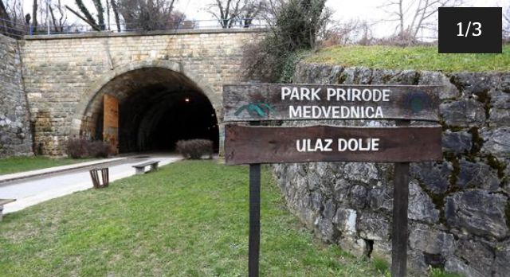
Saturdays: 9.00 a.m.
Meeting point: Zagreb entrance to the Tunnel (on the photo) take the tram no. 14 to Mihaljevac than tram no. 15 to the Tunnel

WALKING/ROLLERBLADING/RUNNING/CYCLING JARUN

Meeting point: at the ramp entrance in Hrgovići street „Jarunski dvori“ (on the photo)

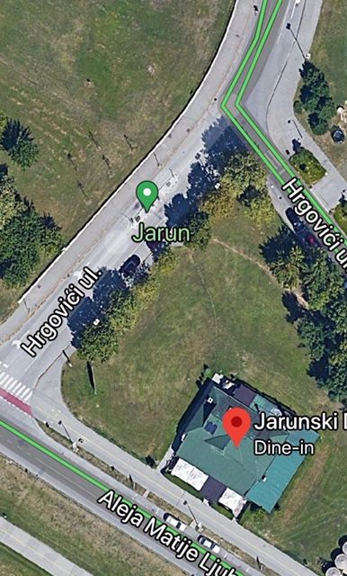

TUESDAYS 14.00-15.30h

WEDNESDAYS 08.00-09.30h

MONDAYS 17.30-19.00h

ENTRANCE TO SPORTS HALL SD UNIVERS VELESAJAM

